o




METHOD OF PROCEDURE
Production Deployment For PostPaid Default Enrollment To Loyalty Programme of Postpaid CBU Consumer And Transaction History LMS UI Time Stamp
version:1.0
Date - 06-01-2026

Table of Contents
1. Introduction 2
1.1. Overview 2
2. Scope 2
2.1. Time Required 2
2.2. Servers Touched 2
2.3. Services Affected 2
2.4. None-Service affecting preparation. 2
2.5. Post installation Monitoring 2
2.6. Communication 2
3. Change installation. 2
3.1. Deployment 2
3.2. Rollback Procedure 3
4. Glossary 3
5. Version Control 3

Introduction

Overview
We are planning to deploy below change:-
- Default enrollment of postpaid CBU customer of loylaty programm should be restricted.
- LMS GUI Transaction history Time Stamp and Description Alignment.
- Keycloak Configuraiton

Scope

Time Required
Here we need the time required for each main activity of the change.
Activity | Time Taken
Backup | 40 mins
Deployment | 2Hrs
Sanity | 2 Hrs
Rollback | 30 mins

Servers Touched
IP Address | Name
10.4.24.21 | mdc01-bss-jump01.safaricomet.net
10.3.124.21 | et02-bss-jump01.safaricomet.net

Services Affected
Lms-account-points-tier-management pod will be restart as part of deployment, In case of any unexpected issues below order will be effected.
And Loyalty GUI Access will not be avialble.
- Onbaording
- Add service
- Lms GUI Access

None-Service affecting preparation.
- We will take back-up of existing template configuration and the table data of WKN_LMS db backup.
- Take tha backup of existing deployment yamls

Post installation Monitoring
Post installation will do end to sanity and will keep eyes on

Communication
No | Resource Details | Phone No | Communication Channel | Email
1 | Shik mahammad arif | 9703619655 | Teams/Hangout | Mohammed.arif@6dtech.co.in
2 | Pragati | 9703619655 | Teams/Hangout | Pragati.nayak@6dtech.co.in

Change installation.

Deployment
- Please find the below db queries to be executed as as part of deployment its and prerequisites db configurations for the deployment.

CONFIGURATIONS | CREATE TABLE LMS_CNFG_ACCOUNT_TYPE (  ID int NOT NULL,  ACCOUNT_TYPE varchar(20) NOT NULL,  DISPLAY_NAME varchar(20) NOT NULL,  PRIMARY KEY (ID)  )  insert into `LMS_CNFG_ACCOUNT_TYPE` (`ID`, `ACCOUNT_TYPE`, `DISPLAY_NAME`) values('1','PREPAID','PREPAID');  insert into `LMS_CNFG_ACCOUNT_TYPE` (`ID`, `ACCOUNT_TYPE`, `DISPLAY_NAME`) values('2','POSTPAID','POSTPAID');  ALTER TABLE LMS_CNFG_AUTO_REGISTRATION  ADD COLUMN SUBSCRIBER_TYPE INT NULL COMMENT '1=PREPAID,2=POSTPAID,-1=ALL' AFTER UPDATED_DATE;

Use visual studio code or from the jump server update the docker image in kustomization.yaml

/home/mohammed.arif@safaricomet.net/safaricom-wakanda/overlay/edge-dc2-cluster/lms

Manage-Account
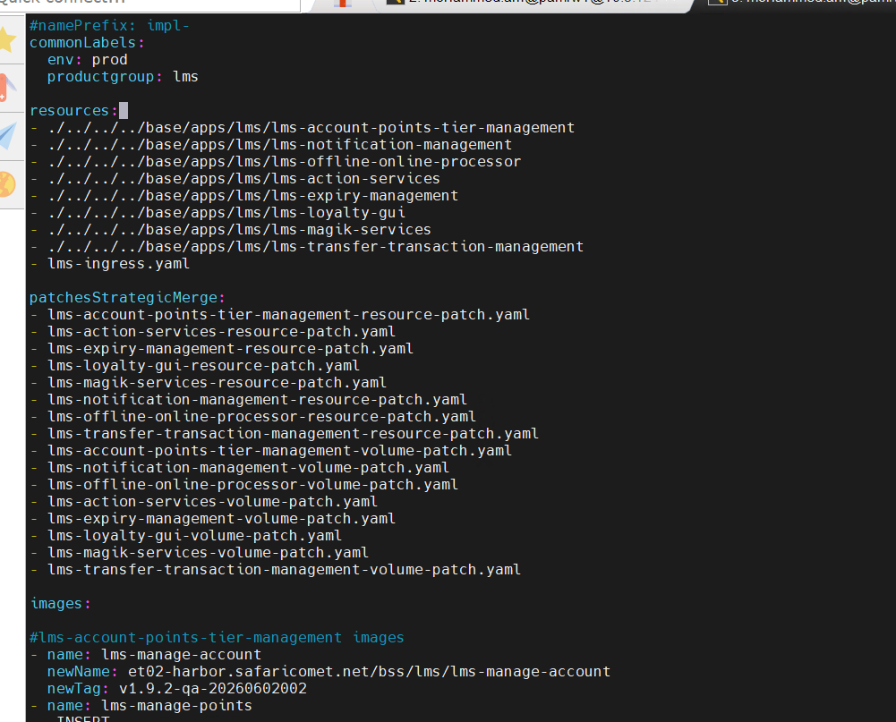

Magikservice and Lms GUI
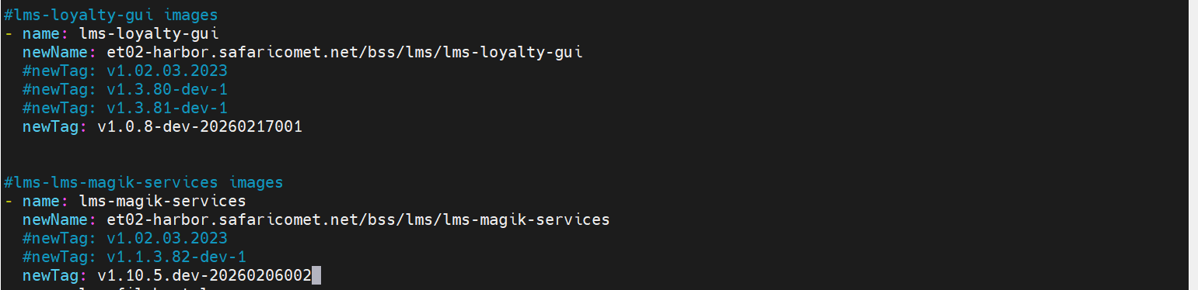

/home/mohammed.arif@safaricomet.net/safaricom-wakanda/overlay/edge-dc1-cluster/lms
Manage-Account
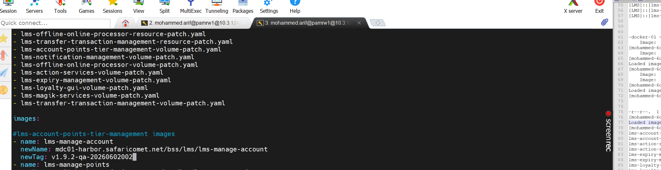

Magik-service & Loyalty Gui

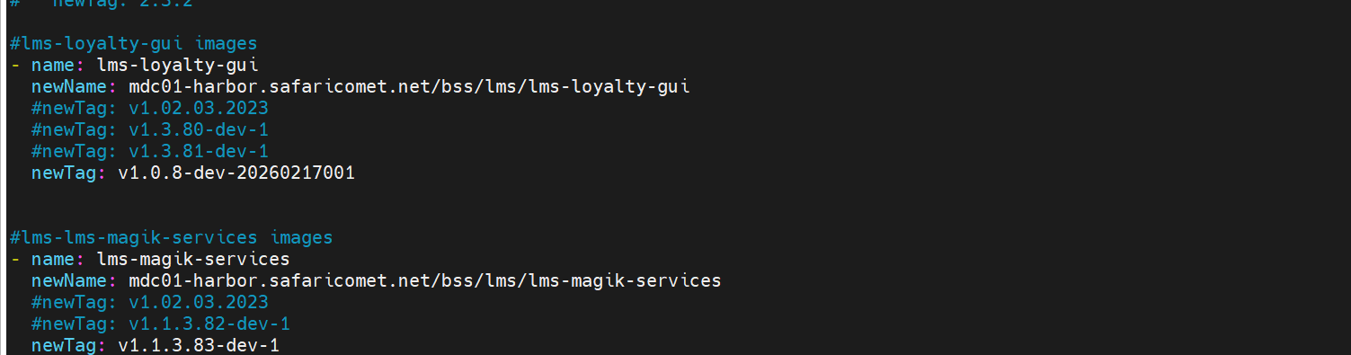

Docker Images
lms-manage-account:v1.9.2-qa-20260602002
Magik-Service: v1.0.5-dev-20260206002
LMS GUI: v1.0.8-dev-20260217001

Keycloak Configuration For the Deployment will handling by the Ops Team, Please find the detailed steps below.

Please find below Clients to be required to to export all the polices and scope resources clients from Safaricom Bp.
1. Safaricom_Magik_SVC
2.Safaricom_Magik_UI

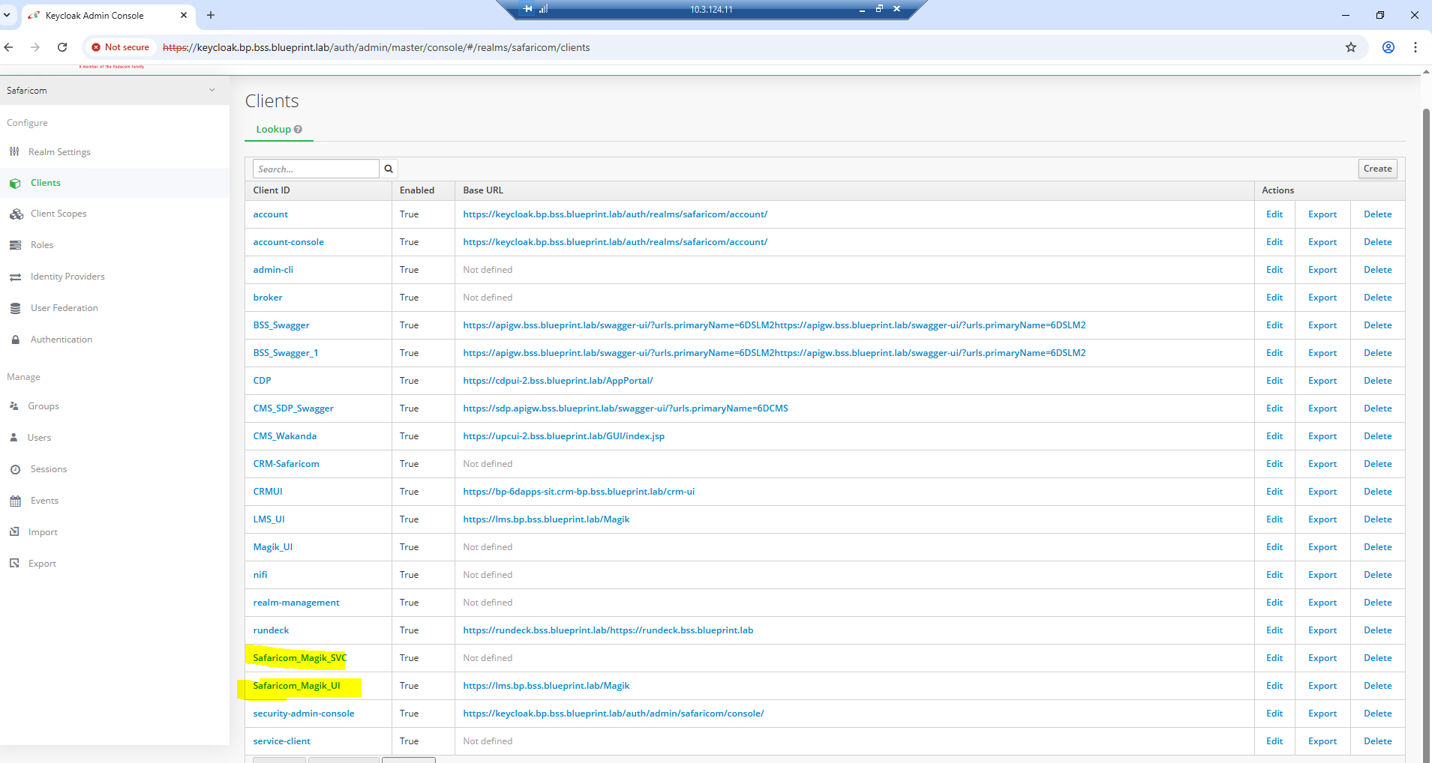

- Create The two new clients from scratch in production environment keycloak.

Safaricom_Magik_SVC
Safaricom_Magik_UI
- Create The roles Manually from the Safaricom Bp to Production on the given the clients

Safaricom_Magik_SVC
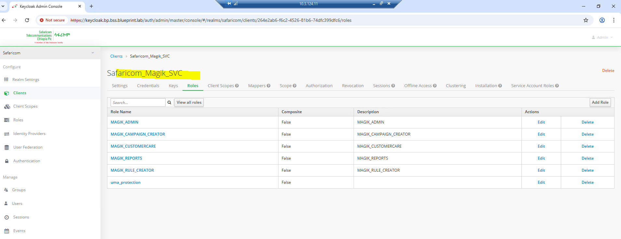

Safaricom_Magik_UI

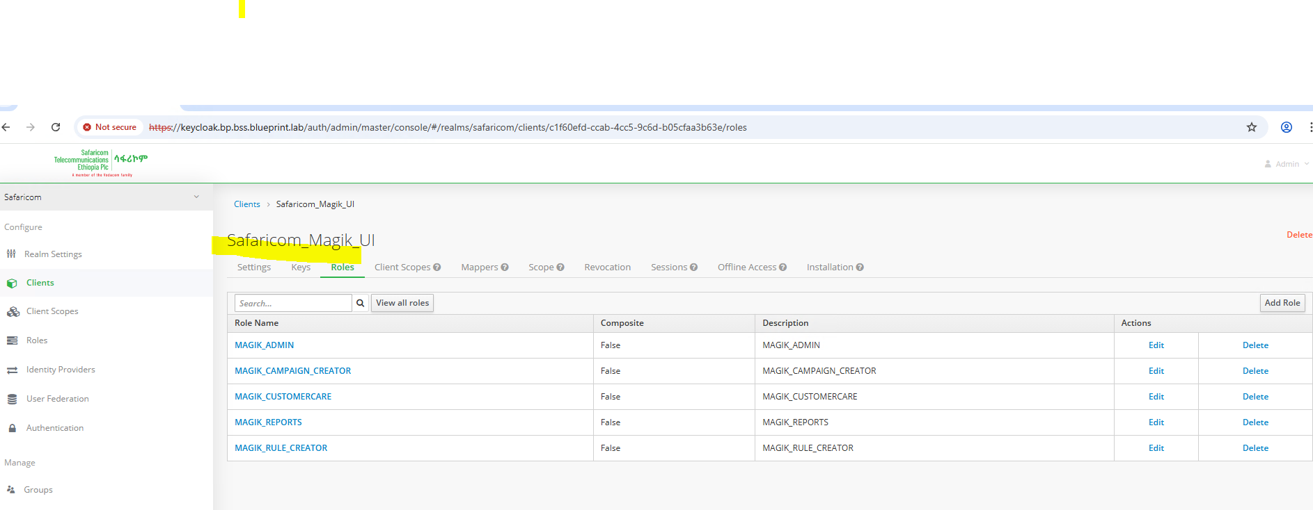

- After Creating the Roles Manually for the above two clients need to export the client json of BP to Production.

Rollback Procedure
- If the pods are not coming up
- If the basic functionality is not working
- If the fixed issues not working as expected

1. Rollback database configuriaton which taken the backup before going to do deployment
2. Restart the applications if required
3. Do the basic sanity

Glossary
TERM | Description

Version Control
Version | Date | Description

